**ARI task**

Using MEP data to model increased activation threshold in GS trials from optimized Go parameters (for facilitation curve and tonic inhibition level), result with only a single facilitation curve.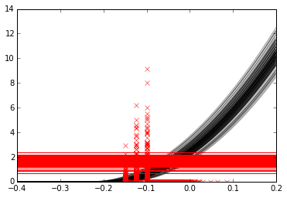

Visualization of Go trial model output.

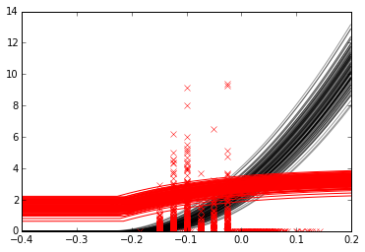

Visualization of GS trial model output – single facilitation curve

Black lines: facilitation curves generated by model; red lines: tonic and increased inhibition levels generated by model; vertically spread red crosses: MEP amplitudes collected experimentally; red crosses spread along x axis: EMG onset times collected experimentally.

params_Go = [0.004, 0.19, 0.02, 1.69, 1.57, 0.31]

k_facGo = 0.004

pre_t_mean = 0.19

pre_t_sd = 0.02

tau_facGo = 1.69

inhib_tonic = 1.57

inhib_sd = 0.31

params_GS = [1.76, 0.18, 0.21, 0.01]  
k_inhib = 1.76  
tau_inhib = 0.18  
step_t_mean = 0.21  
step_t_sd = 0.01

EMG onset times (intersection points between facilitation and inhibition curves) for GS trials with single facilitation curve significantly different from experimental onsets (p < 0.001). Experimental onsets later (av 825ms) than model with single facilitation curve predicts (av 807ms).